Reducing Chinook Salmon Bycatch with Market-Based Incentives: Individual Tradable Encounter Credits

George Sugihara, John Gruver, Donna Parker, & Hao Ye

Summary

A market based bycatch credits-trading plan, using individual (vessel-level) tradable encounter credits (ITEC), is examined that addresses the incentive requirements of the C-2 Motion PPA (box 1). This recommended approach for an Industry Market Incentive Plan is shown to provide robust vessel-level incentives to reduce Chinook salmon bycatch under all levels of Chinook and Pollock abundance and can act cumulatively through time to further reduce overall fleet Chinook encounter rates. Sectors are given fixed annual allocations of salmon encounter (bycatch) credits (1 ITEC = 1 Chinook) in amounts as described in the C-2 motion document under the industry-wide hardcap of 68,392. These are then distributed to individual vessels via the coops according to a specifically designed uniform allocation rule (the Legacy Allocation Rule) that provides vessel-level incentives to avoid Chinook salmon encounters and explicitly addresses each of the C-2 motion requirements. Vessels can use or trade credits within and across sectors to offset salmon bycatch encounters and these transfers of ITEC are moderated by rules (currently under discussion) that further strengthen C-2 incentives and prevent potential abuses (eg. Dynamic Salmon Savings).
Summary of the C-2 Motion PPA Incentive Requirements

Provide incentives at the individual vessel level.
Reward vessels that successfully avoid Chinook and/or penalize vessels that fail to avoid Chinook.
Incentivize vessels to avoid Chinook bycatch at all levels of abundance in all years.
Incentives must influence fishing decisions at levels below the hard cap.
Box 1: C-2 Motion PPA

In overview, the Recommended Industry Market Incentive Plan is designed to reward individual vessels with low (relative to other vessels at that time) encounter levels, by: (1) providing higher credits allocations in the subsequent year (so called “bonus credits”), and (2) creating an additional source of revenue, through the selling of excess credits to vessels that need them. Conversely, it penalizes vessels with high encounter levels by: (1) decreasing credits allocations in the subsequent year (so called “credits penalty”), and (2) requiring vessels that have run out of credits to decide to either buy credits (cost) or lease their Pollock to cleaner vessels having extra ITEC.

The main objective of the Recommended Industry Market Incentive Plan is to create cumulative financial incentives for a fleet-wide reduction of salmon encounters that satisfies the C-2 Motion requirements of vessel-level incentives in a way that maximizes industry profits while minimizing overall Chinook bycatch. The two main components of the plan are the Legacy Allocation component (rules to reallocate ITEC among vessels: address long-term financial incentives) and the Transfer component (rules to regulate ITEC trading between vessels: address both long and short term financial incentives).

The Legacy Allocation component reallocates ITEC away from vessels with higher encounter rates toward cleaner fishing vessels. It creates long term “insurance-like” incentives against catastrophic revenue losses that could occur under the PPA hardcap at times of moderate to high Chinook encounter levels. A particular strength of the Legacy Allocation scheme is that the incentives to avoid bycatch are strongest in years of low salmon abundance, when Chinoonk populations may be most fragile. These are times when the credits also have a higher intrinsic fishery value (not market value) due to the higher value of Pollock harvested per Chinook encounter, implying a higher theoretical upper bound on ITEC market value). Legacy-based reallocation depends on the past record of performance to determine current allocations (akin to a grade point average). This cumulative record creates inter-annual accountability, and dampens the effect of occasional chance events (bad luck) that are not due to individual vessel behavior. It emphasizes the behavioral component of vessel bycatch rates and minimizes the effect of chance encounters. Legacy Allocation creates a cumulative incentive for the fleet toadopt consistent behaviors to reduce overall bycatch and its associated costs.

The Transfer component of the Recommended Industry Market Incentive Plan provides provisions for regulating trading of ITEC that are designed specifically to: 1) discourage chronic bad players who place a drag on the fleet, 2) to reinforce the C-2 motion individual incentive requirements, and 3) to specifically keep the realized bycatch far below the hardcap whenever possible (i.e. through Dynamic Salmon Savings). The Transfer component limits the number of credits that a vessel can purchase and significantly reduces the excess supply of credits especially when Chinook encounters are low (low abundance years, per C-2). It reinforces the long term incentives of the allocation scheme, and as well as the short-term incentives created by trading ITEC, by promoting higher credits prices in times of low encounter rates.
Introduction:

Regional pollution credits trading schemes have been shown to provide effective financial incentives to allow industries over time to evolve new behaviors to minimize emissions, and do so with minimal financial stress. A hallmark example is the New England sulfide emissions market, created in 1990 to regulate atmospheric SO₂ released by the smoke stack power industry (namely coal-burning power plants that contributed to acid rain). Here polluters are able to buy credits from non-polluters to offset their excess emissions allowing the industry to retool gradually without dismantling or taxing the industry externally to drain revenues. Regulators set a cap on emissions and the individual entities are allowed to trade offsets to keep below the cap. Non-polluters are rewarded by collecting revenues from sales of credits while emitters are penalized by buying credits to offset their sulfide emissions. This market-based system provides individual firm incentives for the industry to dramatically reduce sulfide emissions. It is estimated that in the first decade the emissions trading system resulted in SO2 reductions, totaling a 40% reduction nationally from 1980 levels (a 10 million ton reduction annually), the largest and most successful program of its kind designed to date. This market-based incentive system has shown the potential to save up to half of the compliance costs associated with more traditional source-by-source emission limit programs.

Here we will examine a new market-incentive system to reduce Chinook salmon bycatch that is somewhat analogous to the sulfide offsets trading scheme, in its use of credits trading to create individual vesselincentives to reduce Chinook encounter rates. However, in addition, it incorporates an annual allocation formula for credits (individual tradable encounter credits or ITEC) that creates long-term accountability for current behavior or “insurance-like” incentives to reduce bycatch. These allocation incentives promote responsible behavior, are cumulative and operate at all levels of salmon encounter, with incentives for bycatch avoidance being strongest at low levels. Avoiding bycatch in low encounter years creates “insurance” for moderate-to-high-encounter years when credits may otherwise be unavailable: times when many vessels would otherwise deplete their encounter credits before they can fully harvest their Pollock quota. With this allocation scheme, the financial benefits of having additional encounter credits can be considerable. It is shown that even with a hardcap of 68,392, this simple ITEC trading plan can increase industry revenues and reduce bycatch even without explicit behavioral changes, and that more dramatic cumulative benefits accrue when the incentives are explicitly acknowledged.

This analysis will focus on the Inshore Catcher-Vessel sector using annual public data on Pollock harvests and Chinook encounters from 2003-2007, and in part from daily data from 2000-2007 provided by Sea State Inc.
I. Basic Elements of the Plan

- Initial Sector Allocation:

Sectors are given fixed annual allocations of salmon encounter (bycatch) credits (1 ITEC = 1 Chinook) in amounts as described in the C-2 motion document under the industry-wide hardcap of 68,392. For this analysis, the Inshore Catcher Boats sector receives 38,059 credits of which 23,841 are reserved for the A-season and an additional 14,218 credits are allotted at the start of the B-season.

- Legacy Vessel Allocation: (a key element)

Individual vessel allocations of ITEC are made separately for each season (A and B-season computed separately) and it is assumed that 100% of any remaining A-season credits are carried forward to the B-season. 100% carry-forward supports incentive to avoid bycatch in the A-season and keeps ITEC prices high at the end of A-season because of the uncertainty in bycatch levels that will occur in the B season.

A key provision is a formula to reward vessels with low Chinook encounter rates by reallocating extra encounter credits the following year, and conversely penalize vessels with high encounter rates. This creates several different incentives to lower bycatch, including having extra credits as insurance against costly moderate to high salmon abundance years (times when additionalITEC are needed to finish one’s Pollock allocation, butmay not be widely available for sale).

At the start of each season credits are distributed to the individual vessels via the coops according to an allocation formula that takes three factors into account for that vessel:

- Pollock quota for the season
- previous year’s allocation factor for the season (season specific legacy)
- previous year’s bycatch rate for the season (season specific bycatch)

This is summarized in the following general formula:

P_{s,,y, i} = α+ βP_{s, y-1, i} + γQ_{s, y-1, i} (1)

where P_{s,,y, i} is the proportional allocation factor for vessel i at season s (i.e., A-season or B-season) of year y. And the constants α, β and γ are proportional weights that sum to 1 (see Appendix A for complete formula). For simplicity, the analyses based on annual data shown here use yearly averages (dropping i), and the results have the same qualitative behavior as those based on daily/seasonal data. The first term α is the weight given to the Pollock quota, the second term β is the weight given to the previous year’s allocation factor P_{s, y-1, i} (the so-called “legacy” term), and γ is the weight given to the bycatch function Q_{s,y-1, I}, which can take any sensible monotonic form that penalizes high bycatch rates.

Here we will consider the specific case where the bycatch function is linear of the form Q_{s,y-1, I} = δ + εp_{i} where δ and ε are constants and p_{i} is the penalty value for vessel i computed via a penalty function dependent upon the relative bycatch rate of vessel i. (See Appendix A for a detailed description of calculations). In addition, two different weighting schemes will be considered that alter the importance of the legacy component: when α=β=γ=1/3 (equal weighting) and α=γ=1/4, β=1/2 (augmented legacy weighting), and where δ=1/3 and ε=4/3. That is, we will consider

P_{s,,y, i} = 1/3+ 1/3P_{s, y-1, i} + 1/3Q_{s, y-1, i} (2)

or the (1/3, 1/3, 1/3) “equal” weighting.

And,

P_{s,,y, i} = 1/4 + 1/2P_{s, y-1, i} + 1/4Q_{s, y-1, i} (3)

or the (1/4, 1/2, 1/4) “augmented legacy” weighting.

Both of these weighting schemes have a lower bound of 2/3 relative to the initial allocation (based on Pollock) and an upper bound of 4/3. This means that in both formulas (2) and (3) no vessel can lose more than 1/3 of its initial allocation or gain more than 1/3 as insurance against running out of credits in moderate to high salmon abundance years. (See Appendix A for a discussion of bounds and weighting formulas). Most of the analyses here are based on the minimal model having equal weights (2). Except for the speed of convergence (speed at which it is possible to recover from a low ranking) the results here do not differ qualitatively from (3) (see Appendix A-6 for a discussion of convergence). However, eqn (3) may be preferable in some cases as discussed below. In particular, a higher weight given to the legacy component is a way to minimize the random effects of sampling error in bycatch rates (bad luck encounters) and emphasize the consistent intentional behavioral component of variation in ITEC allocations among vessels. That is, a larger β in eqn (1) helps to sort out the behavioral component from the chance component in determining relative seasonal ITEC allocations (penalties and rewards).

Again, it is assumed that these allocation factors are computed separately for each season and that there is100% carry forward of remainder credits from the A-season to the B-season. In practice, a running tab will be kept to let each vessel know in real-time where it stands with respect to the "expectation" of next year's relative allocation. This way there are no surprises, and people will be informed and better motivated. Each vessel can know where it stands relative to the sector (presumably only the data on fleet-wide bycatch will be available to each vessel, with individual vessel performance remaining private information).

As will be discussed the magnitude of the financial incentives created by Legacy Allocations can be large in terms of the value of Pollock quota left unharvested when vessels run out of ITEC and credits are not readily available for sale.

- Transfer Rules

ITEC Supply and Pricing Considerations:

The price of encounter credits will be determined by market factors such as supply and demand and these in turn will be driven by the perception of risk of running out of ITEC allocation or of needing one’s full complement of credits to finish the season. Because of this uncertainty, the price of credits is likely to be highest early in the season when credits will generally be unavailable for sale. Indeed, vessels are more likely to offer credits for sale only after completing their Pollock harvest, when the cost of running out of credits is no longer at risk.

Because individual vessel owners should be willing sellers of credits once the Pollock quota is complete, the supply should increase and price should fall toward the end of the season. During times of moderate to high encounters this could result in a glut of credits at the end of the season, and a fall in credits prices, and a reduction in short-term incentives. Without Transfer Rules to regulate the supply and demand of credits

We will examine two types of transfer rules for ITEC:
- “Buy side” transfer rules
- “Sell side” transfer rules (fixed tax on transfers vs. dynamic salmon savings)

The best outcome is likely to come from using both kinds of transfer rules together to support incentives for Chinook bycatch avoidance during times of low salmon encounters

Buy Side Transfer Limits:

A potential buy side transfer limit might be as follows: “in each season only an amount less than 1/3 of a vessel’s credits allocation for that season may be purchased.” This means that the worst performers (with lower allocations) will be able to buy fewer credits, while the better performers, with larger initial allocations, are further rewardedwith the ability to potentially buy more if needed. This fixed buy-side transfer limit is simple to implement and should not affect the profitability of the sector.

The benefits of this simple rule are:
- It addresses the possible abuse of abundant encounter credits during low salmon abundance years.
- It will not affect the completion of Pollock harvest (as shown in historical simulations)
- It reinforces the incentives provided by the legacy allocation system because vessel ITEC allocations (P) and buy side limits move in tandem.
- Insofar as it depends on the allocation proportion, P, the buy-side limit is more vulnerable to readjustment during times of low salmon abundance.

Again, a buy side transfer limit means that the worst performers (with lower allocations) can buy fewer credits. Thus, it resonates with the legacy system, and augments incentive for salmon avoidance during periods of low encounters.

Sell Side Transfer Limits: (Fixed Transfer Tax versus Dynamic Salmon Savings)

A fixed sell-side transfer tax is not desirable to industry as it can potentially limit the Pollock harvest. It is also not desirable to Chinook conservation either as it is dependent upon transfers taking place. During years of low salmon encounter, very few transfers will take place, reducing the effectiveness of a fixed transfer tax at the times when it is most desirable. Conversely, transfers of ITEC occur more frequently and in greater volume during years of high salmon encounter; at these times, a fixed transfer tax will increase the burden of an already limited ITEC supply, at a time when credits are most needed by the Pollock industry.

Thus, we will consider an adaptive salmon savings rule. This is more complicated, but politically more desirable to Chinook salmon interests than a buy side rule alone, as it represents a true salmon savings rule. A salmon savings rule basically sets limits on the “sell” side of transfers. A salmon savings rule includes a sector specific “salmon savings rate” (SSR) that is applied to each vessel’s “remainder” credits upon the completion of fishing. The sector specific SSR is calculated near the end of the year (B-season) and should have the following characteristics:
- Addresses the possible abuse of abundant encounter credits during low salmon abundance years.
- Will not affect the completion of Pollock harvest.
- And is a function of Chinook salmon abundance.

The idea is to set the sector stranding rate at a reasonable time (determined as a function of how much of the sector Pollock TAC has been caught) before the end of B-season. There is a trade-off between how accurately the stranding rate can be calculated and how soon in the season the fraction can be determined. This tends to happen later in the B-season during low salmon abundance years and earlier in moderate to high abundance years.

The simple dynamic salmon savings rule suggested here consists of two parts:
- A provisional savings rule that applies before the SSR can be accurately calculated.
- Determination of a valid SSR far enough in advance of the end of the season to be useful. SSR is the fraction of “remainder credits” that must be retired. Remainder credits are credits that a vessel did not use to fish its full Pollock allocation.

(i) Provisional Salmon Savings Rule:
Note that prior to setting the seasonal SSR rate, transfers are allowed “from” boats but only up to some fixed percentage of their “remainder” credits. Remainder credits = a vessel’s credits left after filling it’s B-season quota + credits sold prior to filling quota. Remainder credits include carry-forward vessel credits from the A-season.

For example, if a cap is set so the largest variable Salmon Savings rate is 40% (a number that historically will not limit the harvest), then prior to setting the dynamic stranding rule, boats that have finished fishing early can only sell up to 60% of their remainder credits. This means that if a vessel has wishes to sell 60 credits early in the season, it must keep 40 ITEC in reserve until the SSR

2) Calculating a savings rate:
Numerical experiments with the Inshore daily data suggest that calculating the savings fraction when 2/3 of the sector Pollock quota are caught (2/3 sector TAC) gives the best result, in terms of estimating the credits needed to complete the season. This is the “estimated total sector by-catch for the B-season.” This estimate normally occurs between August 29 and Sept 16 (see figure and table below). This tends to happen later in low salmon abundance years (when fewer transfers are needed) and occurs earlier in moderate to high abundance years.

The “estimated number of surplus credits” in the table below is the (current number of credits for the sector on the date that the stranding rate is calculated) - (estimated total B-season bycatch for the sector + buffer). Here the buffer is 5000, to account for error in the estimates of total sector by-catch.

The final “allowable stranding rate” would then be (the number of estimated surplus credits) / (current number of credits for the fleet). It is called an” allowable stranding rate” in that under this stranding rate, the Pollock harvest for the sector would not be limited by the availability of salmon encounter credits. These numbers are shown in the blue region of the table below. Notice that in high abundance years the stranding rate is 0%. and in low salmon abundance years the stranding rate can be as high as ~79.6%. That is, in year 2000, we would be confident of fishing the entire Pollock quota (with margin for error) if the stranding rate were set at 79.6%. However such a high rate would put a damper on trading before the rate was posted (albeit, in 2000 no transfers were ultimately necessary). Alternatively, we can set a cap on this rate (say 40%), so that early trading can occur more readily if needed. Then any year where the estimated stranding rate is above 40% would automatically get set at 40%. I think that agreeing to strand up to 40% would be thought of favorably by the Chinook salmon interests.

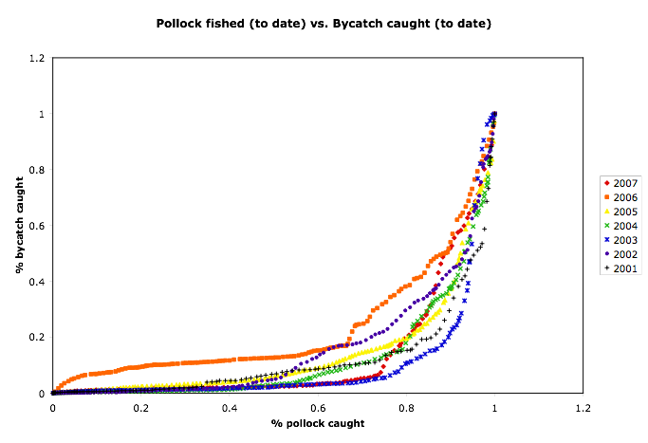

 | Dynamic Stranding Rate (at end of B season) |  |  |  |  |  | UNKNOWN | UNKNOWN
year | date when 2/3 Pollock caught | sector credits remaining * | bycatch caught ** | predicted total bycatch (for season) + buffer | estimated surplus credits | allowable stranding rate | % bycatch caught *** | actual total bycatch (for season)
2000 | 16-Sep | 37001 | 254 | 7540 | 29461 | 79.6% | 35.7243% | 711
2001 | 11-Sep | 31578 | 277 | 7770 | 23808 | 75.4% | 10.0984% | 2743
2002 | 5-Sep | 24955 | 1655 | 21550 | 3405 | 13.6% | 17.2002% | 9622
2003 | 2-Sep | 24318 | 256 | 7560 | 16758 | 68.9% | 3.5834% | 7144
2004 | 31-Aug | 25859 | 1890 | 23900 | 1959 | 7.6% | 9.0327% | 20924
2005 | 29-Aug | 21122 | 4142 | 46420 | (25298) | 0.0% | 12.2784% | 33734
2006 | 10-Sep | 12182 | 3591 | 40910 | (28728) | 0.0% | 16.9555% | 21179
2007 | 2-Sep | 14848 | 1465 | 19650 | (4802) | 0.0% | 4.3327% | 33813
 | * sector credits remaining includes 100% carry-forward and transfers
 | ** bycatch caught up to the first stranding date (when 2/3’s Pollock caught)
 | *** % bycatch caught when stranding rate is calculated

Discussion:
A stranding rate by itself may not be effective at preventing transfer abuse, as the definition of what constitutes the end of fishing may present problems, especially in consortia of boats that fish for a common company one boat may hold it’s last ton of Pollock unfished to allow the rest of the group to use it’s credits, before they are retired. However, this may not be very economic, as a strong disincentive for doing this comes from the legacy system. With higher by-catch at the end of B-season, there should be less motivation to fish at that time. Coops or companies that conspire toward this strategy face a larger inevitable cost of diminishing it’s credits every year.

Although such behavior may be uneconomic and irrational, potential problem scenarios such as this need to be considered.

Notwithstanding, in combination with legacy allocations and a buy-side limit, it is likely that standing should be helpful at addressing abuse. Moreover, stranding is a good political tool that should not impact the Pollock fleet negatively. The simpler and less conspicuous buy side limit will likely be more effective as a transfer limit by itself, and it resonates with the legacy system which can be very iron-clad to abuse.

The estimated instantaneous value is the extrapolated fishery value of a Chinook caught based on the remaining IFQ and season-to-date bycatch at that point in time. That is, Instantaneous Fishery Value (or instantaneous intrinsic non-market value) = [value of Pollock remaining in the season] / [bycatch rate to date in that season]. Notice that this value is inversely proportional to bycatch rate. That is to say, the value of a single Chinook salmon encounter credit to vessels with low bycatch is higher than to those with high rates of bycatch. Vessels with low encounter rates are more efficient and can harvest more value in Pollock from each ITEC (encounter credit).

An expected price is not known, but will likely be near the price floor, when encounter credits become available after vessel Pollock quota have been filled. However during times of high Chinook abundance, due to supply demand dynamics, the excepted price may climb toward the implied fishery value of a credit (the intrinsic value). See Appendix for calculations showing how this upper bound value of a credit varies with time and season in each year.

The conservation benefit to Chinook is clear. The price floor as well as the intrinsic fishery value (non-market value) tends to be higher in low salmon abundance years than in high salmon abundance years. Also, the price floor is highest when the Pollock fleet is least likely to need to trade credits. This is clearly a win-win outcome. However floor pricing and consequent trading will likely only have a modest affect on behavioral incentives, which as discussed below are more likely to be driven by the larger economic motivation created by credit allocations. Nonetheless, both factors, allocation incentives and floor pricing with trading, work in harmony to align economic success with fishing behavior.

4) Handling Chronic Offenders with the “2-Strikes Rule:”

Chronic bad players who consistently have high bycatch rates relative to the rest of the fleet can place a drag on the overall performance of the fleet and harm its standing with regard to the Chinook salmon interests of western Alaskans. They may be content with the minimal 2/3 allocation and be willing to wait until later in the season when credits become more available as individual Pollock quota are filled and/or vessels are more comfortable with selling remainder credits at low prices. They may not care about the risk that next year may be a moderate to high abundance year, when credits may not be readily available, and may be willing to put their businesses at risk. Moreover as discussed below, the credits may be uneconomic for the worst players, because they are worth less in terms of expected return on Pollock (having a lower intrinsic fishery value, see glossary and discussion below in section II-5).

One possible way to handle this is to implement a 2-Strikes Rule that suspends credits trading privileges from such repeat offenders in all seasons until they can demonstrate that they can move out of the worst category in any one season. It is ultimately up to the industry to decide the details of this rule and what defines this worst category (eg. 3 standard deviations below the mean for 2 years running, or near the bottom of the list for 2 years running). Such a rule could quickly weed out the few worst players, and would likely only need to be in effect for some initial period. It has not been implemented in the current study.

To summarize, being a chronic offender is risky and uneconomic for several reasons:
- They will tend to run out of credits quickly because of their lower allocation.
- They will need to buy credits at a floor price that may not be economic given their high bycatch rates.
- They risk losing trading privileges.

II. Incentives/Issues

- Industry costs associated with non-transferability of credits.

Without a system for transferring Chinook salmon encounter credits individual vessels will run out of ITEC, and Pollock could go unfished resulting in significant revenue losses for the Pollock industry. These losses can happen even during low to moderate salmon encounter years. Figure 2 below illustrates the timing of how many vessels run out of credits in each season under the proposed Inshore sector hard cap of 38,059 (including 100% A to B carry forward).
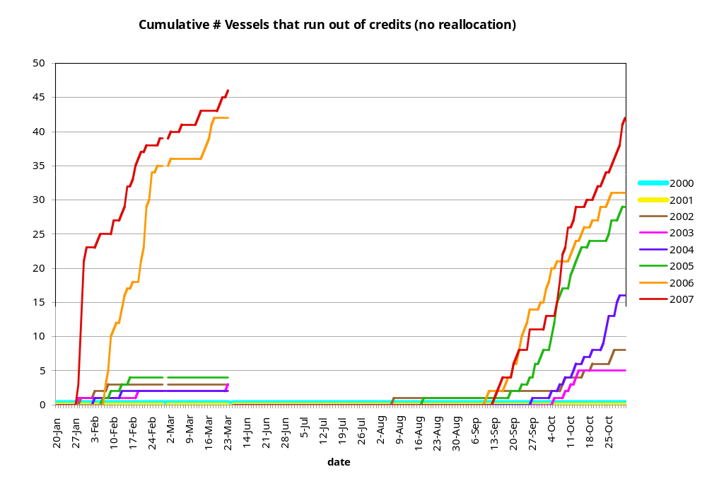
Figure 1. Timing and cumulative numbers of vessels in each season that would have run out of encounter credits under the maximum Inshore sector hard cap of 38, 059 (from new daily data provided by Sea State Inc. with no reallocation).

What is interesting here is that in 2000 and 2001 apparently no vessels would have run out of ITEC (hence no trading would be required). However, in other low salmon encounter years, 2002, 2003 and in the moderate salmon abundance years 2004, 2005, an increasing number of vessels would have run out of Chinook salmon encounter credits. This suggests that while no trading was required in 2000 and 2001, that it would have been required in all of the following years.

The sector revenue loss associated with not being able to trade encounter credits under a hard cap scenario can be considerable. These costs are illustrated below in Figure 3, and can exceed $62m in one year. The risk of catastrophic losses due to unharvested Pollock in any given year should provide motivation for industry to adopt a plan for transferring credits, in addition to rewarding lower bycatch rates with additional ITEC allocations. In addition, individual vessels who may run out of credits, even in moderate encounter years, will be incentivized to lower their bycatch rates to make maximal use of their ITEC allocation and to secure a sufficiently high ITEC allocation in subsequent years.

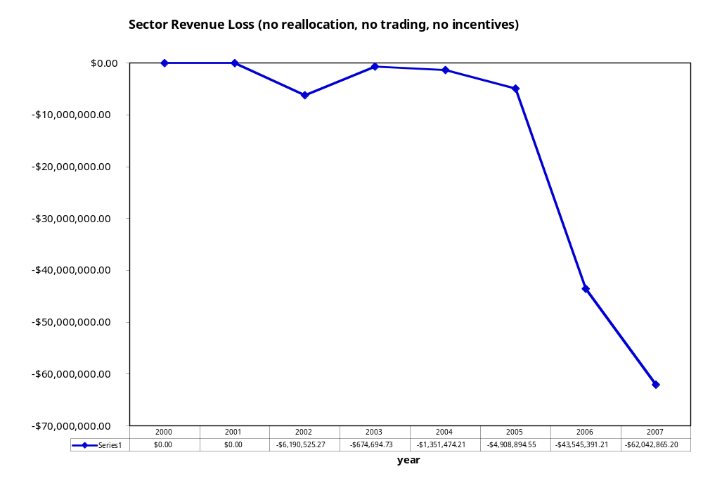
Figure 2. Annual sector revenue losses that would have been incurred under the maximum hard cap if no reallocation, no trading, and no bycatch avoidance incentives were in place. This calculation is based on the new daily catch data from Sea State Inc. and the assumption that the A-season price for Pollock is $0.20/lb and the B-season price is $0.12/lb.

- Trading encounter credits even without explicit incentives to avoid bycatch can increase industry revenues and reduce fleet bycatch.

The following figure (Figure 4 below) illustrates a hypothetical scenario where reallocation (using eqn 2 above) and trading occurs by the following simple rules:
- Credits are only made available to trade when a vessel finishes its quota for the season. The only sellers are those who have finished fishing that season.
- Credits are transferred as soon as they are needed and available to the vessel(s) that have run out of credits and for whom the intrinsic value (non-market value) is highest, thus will be most likely to want to buy them. As credits are made available, transfers are made in that order. Basically, as they become available, credits go to those vessels who ran out of credits and for whom they have the highest value (like water running down the tiered basins of a fountain).

The remarkable thing here (Figure 4, below) is that this shows that there can be significant revenue advantages to credits trading for the sector as a whole, despite the fact that there is no explicit individual motivation to avoid bycatch. Although the effect is modest, the natural dynamics of the allocation scheme and the trading model by itself can enhance revenues, and reduce bycatch for the fleet as a whole.

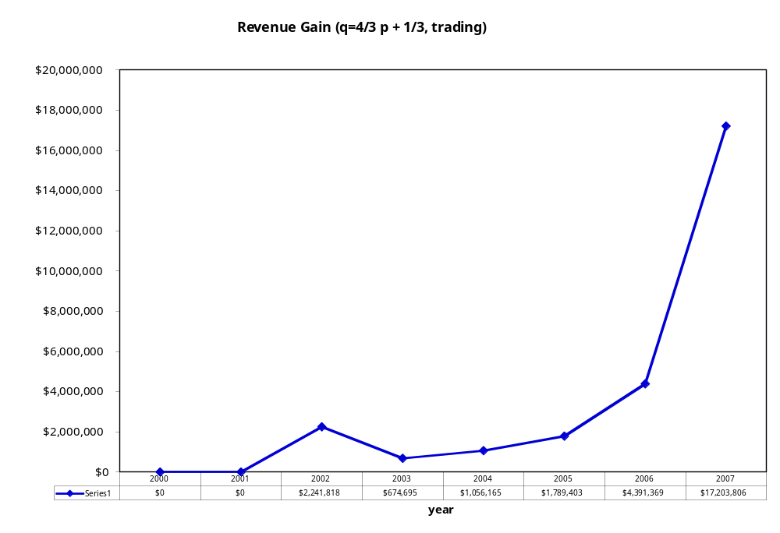
Figure 4. Trading Chinook salmon encounter credits (ITEC’s) even without explicit incentives to avoid bycatch can help to maximize industry revenues. (Based on new daily data as fig 3).

Note that no trading occurred in 2000 and 2001, as all vessels would have made it through the season without running out of credits.

- Incentives and Issues related to the allocation scheme.

The main incentive mechanism for the tradable encounter credits model is the allocation of credits based on current and past (legacy) encounter rate behavior. As we have already seen (Appendix B) the intrinsic fishery value of credits can be very high, and in years of high salmon abundance the cost of forgone Pollock under a Chinook hard cap can represent a catastrophic loss. Having extra Chinook encounter credits or so-called “bonus credits” over and above the initial allocation based purely on Pollock makes the value of avoiding current encounters high if in the future there are years of high or moderate salmon abundance. This requires forward thinking similar to buying insurance. Having extra credits reduces the expense of risks associated with encountering years of moderate to high salmon abundance.
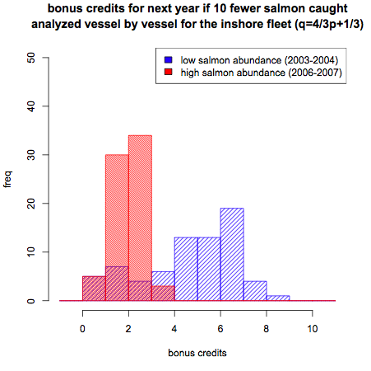
Figure 5. Bonus credits (extra ITEC) achievable with 10 fewer Chinook salmon caught. This is analyzed vessel by vessel. (Based on original annual data). The additional revenue per bonus credit in the 2007 A-season (assuming the vessel would have otherwise run out of credits) is ~$7k/credit. Allocation provides strong motivation in terms of potential cost.

Of special significance is the fact that this allocation scheme operates more sensitively during years of low salmon abundance (Figure 5). That is, vessels are more strongly rewarded/penalized for fishing behavior during sparse salmon abundance years. Additionally, the intrinsic fishery value of the credits is higher at times of low salmon abundance (Appendix B). However, depending on perceived salmon abundance and the abundance of credits, the actual trading price may be lower and closer to the price floor (which is also higher at times of low salmon abundance).

- Incentives related to trading ITEC.
If vessel-owners believe they have excess of credits in any given year they can put them up for sale on an electronic market site once the floor price has been set. This could represent significant extra revenue, especially if there is significant asymmetry in performance among vessels. Similarly, if a vessel owner needs to buy credits he is required to pay the market price, which may or may not be higher than the seasonal price floor. This incentive structure is similar to the incentives for trading pollution offset credits, however it also involves a floor pricing mechanism that is sensitive to salmon abundance. It is not known whether credit pricing will be sufficient to deter chronic bad performers who respond only to current incentives as trading is not always required (eg. 2000 and 2001).

- Legacy Incentives

The second term of the allocation formula 1 is the so-called “legacy” component that incorporates past behavior into the current allocation scheme. This component serves three important functions:

- It moderates the random component in seasonal year-to-year variability in seasonal bycatch that is due to chance, and tends to amplify the behavioral component. One of the problems with any performance related reward/penalty system is that it is almost always subject to randomness in some form. Chance is part of life, but one wants to minimize this as much as possible without also destroying the incentives created by rewarding/penalizing differences in performance. Separating out such random variation in bycatch rates (eg. sampling error or bad luck), from variation due to behavior is difficult but is handled somewhat by the Legacy component, which rewards and penalizes consistent behavior. This problem is addressed in the present system in several ways (see Appendix A for a fuller discussion), but it is usually problematic to try to separate natural sampling variation, from variability due to behavior without using historical data that can capture consistent patterns of behavior. Thus, boats in the same area may have different bycatch rates partly due to sampling variation and partly due to behavior and this is difficult to sort out without assumptions that may be questionable. The legacy component dampens out variation due to accident and tends to highlight variation that identifies behavior.
- The legacy system provides carrot and stick incentives for long-term accountability in behavior. It encourages forward thinking and a chance to improve toward the upper bound allocation of 4/3 the initial allocation. It also provides the “stick” of having only 2/3 the initial allocation to fall back on. This can be a strong incentive on behavior.
- The legacy system provides cumulative incentives (incentives that begin year 1 and continue identically in all years) that should result in a steady evolution toward fleet-wide improvement in encounter rates.

III. Hypothetical Modeling of Incentives:

A simple behavioral self-correcting model is examined to model the action of cumulative incentives to lower bycatch. The model assumes that a vessel’s motivation to improve behavior will be inversely related to it’s recent bycatch rate (if you are at the bottom of the list you will try harder, and if you are at the top you may rest on your laurels). The allocation-transfer simulation described in 2 above (fig. 4) was combined with an incentive model that was fit to reflect maximum intentional changes on the order of 25% of the observed changes in bycatch rate. That is to say, that the model is parameterized so that the directional changes in bycatch rate are maximally ¼ the magnitude of historically observed variations in bycatch rate.

Briefly, the incentive to reduce bycatch is modeled as a simple function of bycatch rates as follows. We used actual vessel bycatch rates and defined the simple incentive function:

incentive = 1/[1+Q] * ψ,

where ψ = ¼ in this simulation to represent the plain assumption that 25% of the variation in observed encounter rates can be due to behavior. Here the

incentive multiplier = 1 – incentive.

And the cumulative incentive multiplier CIM is simply

CIM(t+1) = CIM(t) * incentive multiplier

And,

Market incentive adjusted bycatch = CIM(t) * actual bycatch at time t.

These dynamics are then incorporated into the simulation in II- 2 above, and run forward to produce the following results shown in Figures 6 and 7. The results are similar but more dramatic than the earlier simple allocation and trading results (Figure 4) without rational incentives to improve relative standing in the fleet with respect to TEC allocation.

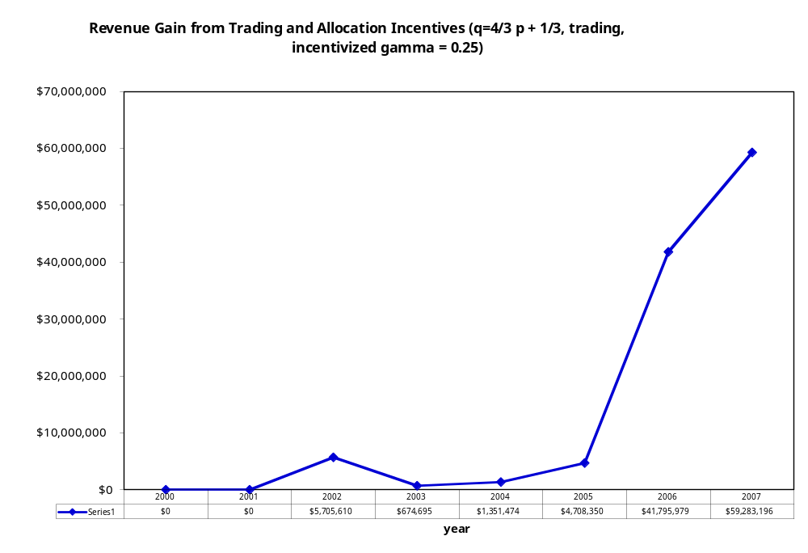
Figure 6. Hypothetical revenue gain for the Inshore sector from trading and allocation incentives to avoid bycatch assuming a sector maximum hard cap of 38,059.
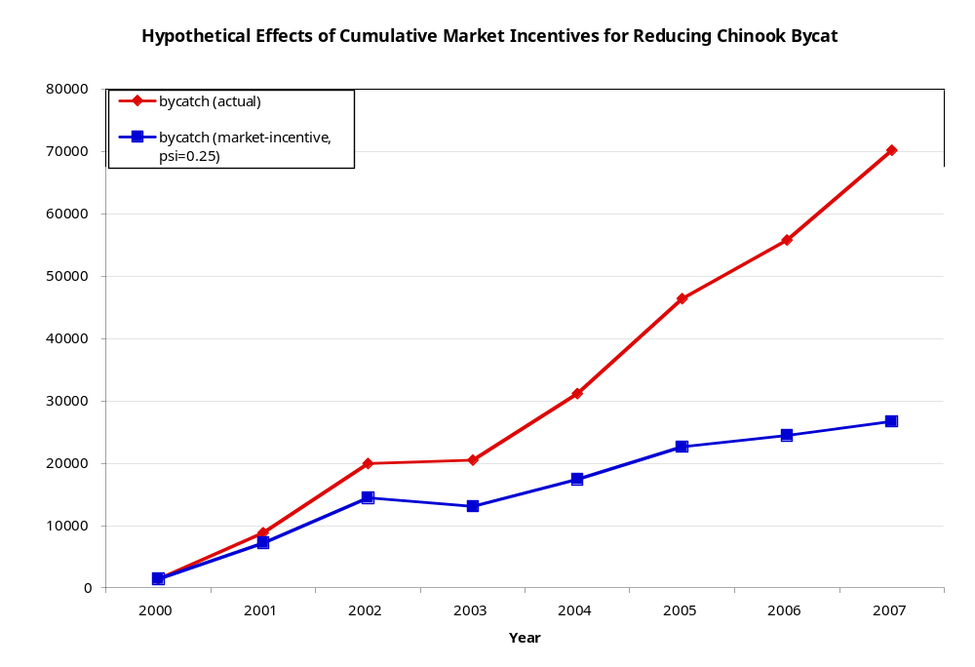
Figure 7. Effects for the Inshore sector of cumulative market incentives for reducing Chinook salmon bycatch under a sector maximum hard cap of 38, 059.
Modifications For Further Study:

- Stranding of encounter credits at the end of the year is politically attractive in terms of it’s apparent simplicity in controlling potential abuses in ITEC trading with nominally priced credits. While I believe that the current system largely addresses abusive trading with a floor pricing provision, it would be worthwhile to examine stranding rules that would impact the industry minimally while at the same time would provide the most comfort to Chinook salmon interests. It is clear that a fixed end-of year stranding rule would impact the industry negatively during moderate and high Chinook abundance seasons, (though in principle it should have little effect in the extreme abundance years when everyone runs out of credits). It is also clear that during times of low salmon abundance a large stranding fraction is tolerable. The political capital that can be gained from a dynamic stranding rule that can promise to strand a large fraction when it will make little difference to the Pollock harvest (though not benefit the worst players) is highly desireable. I think it may be possible to construct a reliable dynamic stranding rule that is a function of salmon abundance, and this may be worthwhile to pursue.

- It may be desirable to allow coops to impose a small 3% (not exceeding 3%) tax on all vessel credits allocations to create an Emergency Fund for extreme bad luck cases. This small "emergency fund" could be used to help bail out any vessel that the coop determines had genuine bad luck. Any remainder credits could be put on the market by the coop toward the end of the year to raise revenue. The bad luck event (as deemed by a coop, or better yet a sector) could be incorporated into the legacy system (or not) by adjusting the bycatch rate to not fully reflect this event (say cut the number in half for that tow). This can only happen occasionally per vessel (eg. once per vessel in 7 years).

GLOSSARY OF TERMS:

1) Intrinsic Fishery Value = [(sum value of sector Pollock remaining at time t to the end of the season) / (sum sector actual bycatch remaining to the end of the season)] x [fraction of vessels in sector still fishing]
Note: this last term averages in the 0’s for the value when a vessel fills it’s quota. Thereby giving a weighted average to reflect the differences among vessel allocations and quota.

2) Instantaneous Expected Fishery Value = ( value of Pollock remaining at time t) / (cumulative bycatch rate at t)

3) Bycatch rate = #Chinook/mt Pollock

4) Back-of-the-envelope Upper Limit Bycatch Rate: 68,000/ 1,000,000 mt = 0.068 = bycatch rate suggested by 68k HC and TAC of 1,000,000 mt.

Appendix A: Technical Issues Regarding the Allocation Formula

Here we examine several technical issues related to the allocation formula (1)
P_{s,,y, i} = α+ βP_{s, y-1, i} + γQ_{s, y-1, i}

1) Scaling:
The proportional allocation formula (1) is transformed into number of credits as follows:

Credit Proportion_{i} = P_{s,,y, i} IFQ_{s,y,i}

Because the sum of this product across vessels does not necessarily = 1, it is necessary to divide by the sum of these credit proportions over all active vessels in the sector, ΣCredit Proportions. That is,

# Credits_{i} = Credit Proportion_{i} / (ΣCredit Proportions) * # sector credits for the season

2) Upper and lower bounds for proportional allocations:
When the weightings are such that α = γ the lower and upper bounds on P will depend only on the bounds for Q. Thus, for both equations (2) and (3) the bounds for P are the same [2/3, 4/3] when the bounds for Q are [1/3, 5/3] (obtained when Q = 1/3 + 4/3 p_{i}). The following bounds for P apply to the following parameter settings for δ and ε in Q: (in order of wide to narrow limits):

[1/2, 3/2] Q = 2p_{i}

[2/3, 4/3] Q = 1/3 + 4/3p_{i}

[3/4, 5/4] Q = 1/2 + p_{i}

3) Specific forms for the penalty function p:
In general p can be any function having a range from 0 to 1 that rewards low bycatch behavior and that penalizes high bycatch behavior. The performance measure chosen here involves computing a z-score for bycatch rate and converting via linear scaling. Vessels with z-scores less than -2 receive a p of 0, and vessels with z-scores greater than 2 receive a p of 1. Vessels with z-scores in between -2 and +2 have p computed as p = z/4 + 1/2. Note that this penalty function provides equal incentive for the vast majority of vessels. Here, the incentive is directly related to the slope of the penalty function: a greater slope indicates a greater change in credit reallocation for the same change in bycatch rate.

An alternative penalty function was considered that uses each vessel’s z-score to compute a cumulative p-value based on a normal distribution. This penalty function would create the highest incentives in any year to the most vessels. These are the vessels in the middle of the pack can move up and down in Q value more quickly than those at the extremes. It also protects vessels that are at the extremes (in particular the lower extreme of high encounter rates). This is a way to helping to buffer against bad luck. That is, with this form of Q incentive to improve is large for the most vessels, and "occasional " accidents are buffered. The main disadvantage is that it exposes the average player to more variation. More incentive and more variation are two sides of the same coin.

Another possibility is to construct a function for Q that is flat in the middle so that average vessels will see very little change (the fleet will have less incentive) and so that the extreme bad luck year is more readily penalized. The advantage of this kind of function is that it will dampen the effects of random chance for the middle of the pack but at the cost of creating less incentive for the pack as a whole to improve. Overall, tinkering with Q makes more sense in systems that lack a legacy component to help buffer random events. Though modifying Q still might merit some additional experimentation, the main idea is to create incentives to shift the whole fleet over to have lower bycatch from year to year. That said, the real issue is not so much what the p-value is (how sensitive it is to changes in z-score) but how the "allocation" actually varies, and the legacy system gives some buffering capacity there.

4) Computation of z-scores:
The variance in bycatch rates among vessels can be attributed to two factors: chance encounters with pockets of Chinook salmon, and consistent behaviors to reduce bycatch. One reasonable expectation of the Industry Market-Incentive Plan is for the distribution of bycatch rates among vessels to decrease over time as vessels exploit the same behavioral changes to reduce bycatch rates. A larger proportion of the variation in bycatch rates would then be due to random chance and not intentional behavior on the part of vessels. Since z-scores are scaled to the standard deviation of the bycatch rates, large changes in z-scores may become due to random chance. To mitigate this problem, we use an estimated standard deviation based upon a sector-wide bycatch rate. (equivalent to a weighted average of individual vessel’s bycatch rates) This calculation is based on historical data across the Inshore Catcher-Vessel sector, the Mothership sector, and the Catcher-Processor sector. (figure A-1)

Because small vessels are subject to more sampling error (figure A-2), we also use a corrected standard deviation to reduce the effects of random noise due to vessel size. This random noise varies with the inverse square root of 1 + pollock allocation %. Thus, we correct standard deviation in the following way:

sd_{i} = sd * sqrt(1 + avg. pollock allocation %) / sqrt(1 + pollock allocation % of vessel i)

This adjusted standard deviation is then used to calculate the z-score for vessel i:

z_{i} = (fleet wide bycatch rate – bycatch rate of vessel i) / sd_{i}

Note that this calculation for z-score is of the opposite sign of the traditional calculation of z-scores. Thus, high bycatch rates (corresponding to poor performing vessels) map to low (i.e. negative) z-scores and low bycatch rates (corresponding to the best performing vessels) map to high (i.e. positive) z-scores.

Figure A - : standard deviation of bycatch rates as a function of sector total bycatch rate

Figure A - : Smaller vessels show higher variability in bycatch rates. (annual data)

6) Convergence:
The legacy weighting not only affects the magnitude of the variance in credit allocations P, (a smaller γ results in lower year to year variation in P), but it also affects the rate at which one can move in the pack in terms of allocations due to directed behavior. The graphs below (Fig A-2a,b) show the extreme cases realized by the two different weighting schemes: (1/3, 1/3, 1/3) and
(1/4, 1/2, 1/4).

If one uses the weighting scheme (1/3/, 1/3, 1/3) the legacy component receives less weight than (1/4, 1/2, 1/4).

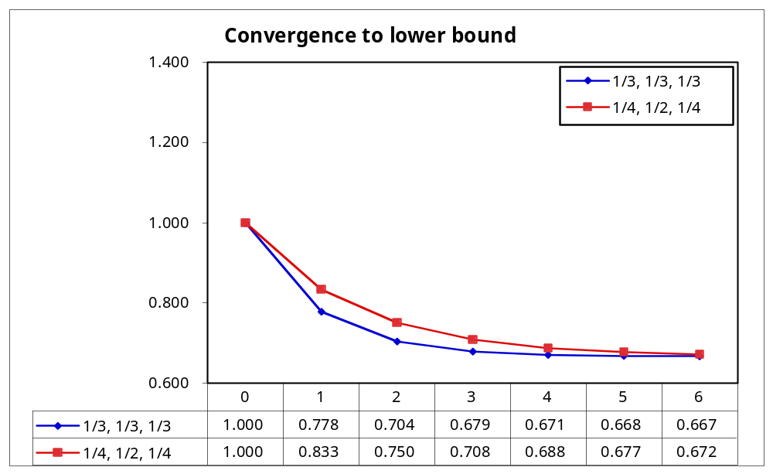
Figure A-2a: Comparison of two weightings of of the legacy component. Assuming p_{i}=0, worst case. The more heavily weighted legacy component converges slower.

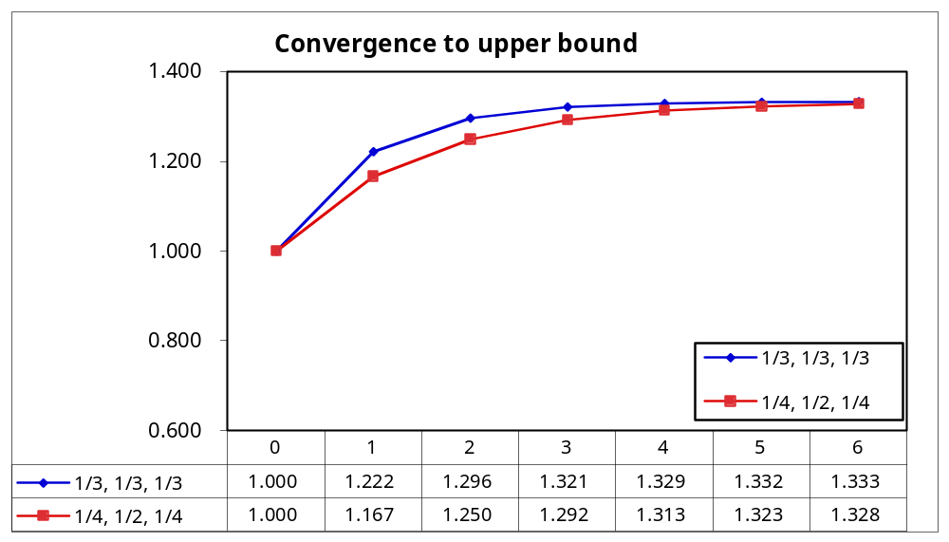
Figure A-2a: Comparison of two weightings of of the legacy component. Assuming p_{i}=1, best case. The more heavily weighted legacy component converges slower.

Appendix B: Simulation Results with a Fixed Transfer Tax or Dynamic Salmon Savings

APPENDIX C:

Temporal Analysis of Credits Supply and Intrinsic Fishery Value of Credits 2003 – 2007.
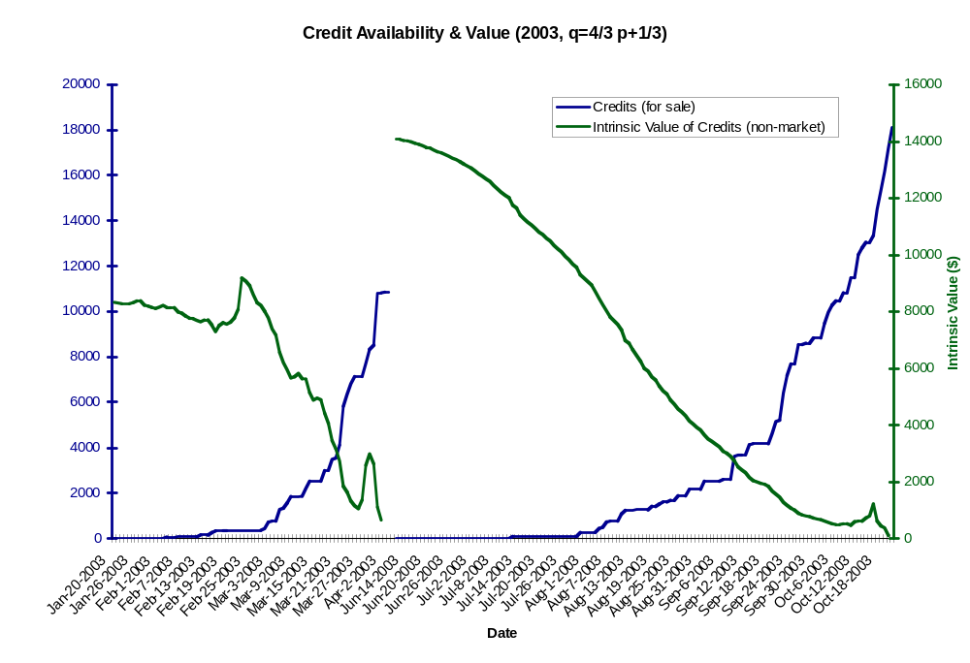

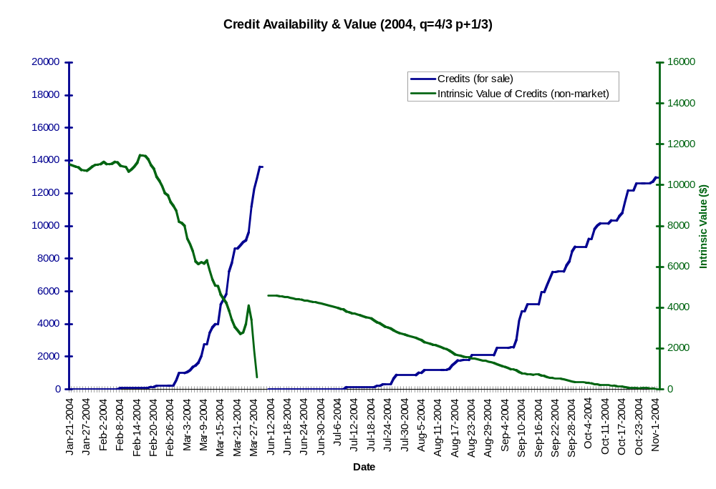

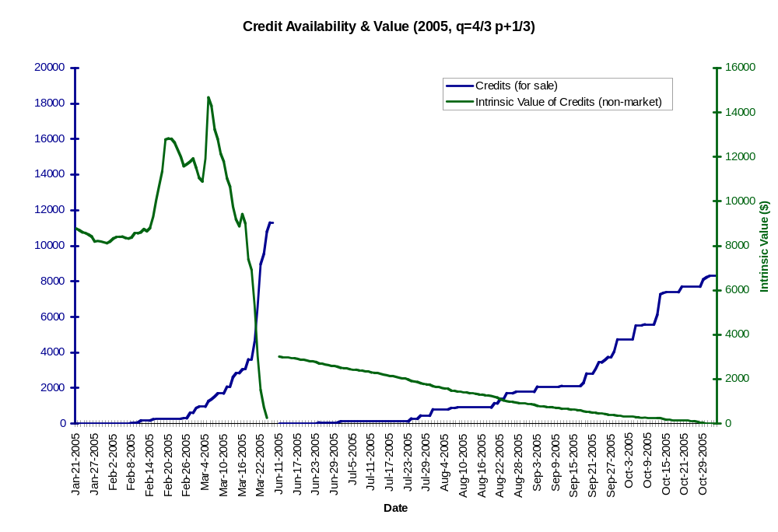

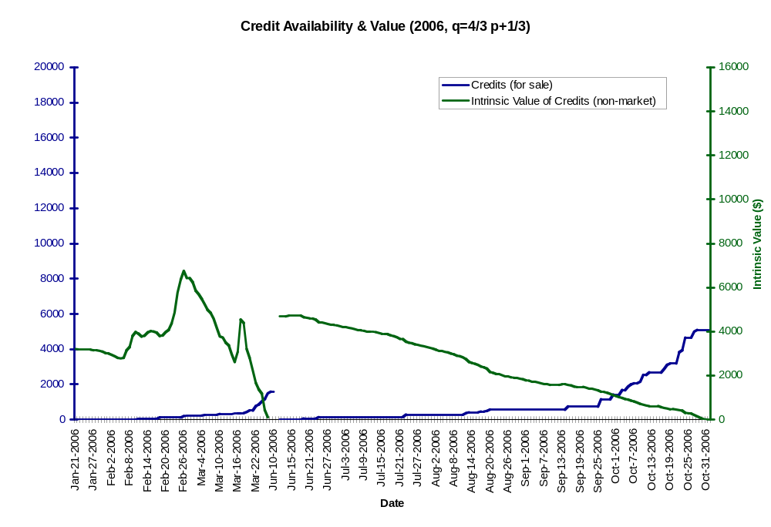

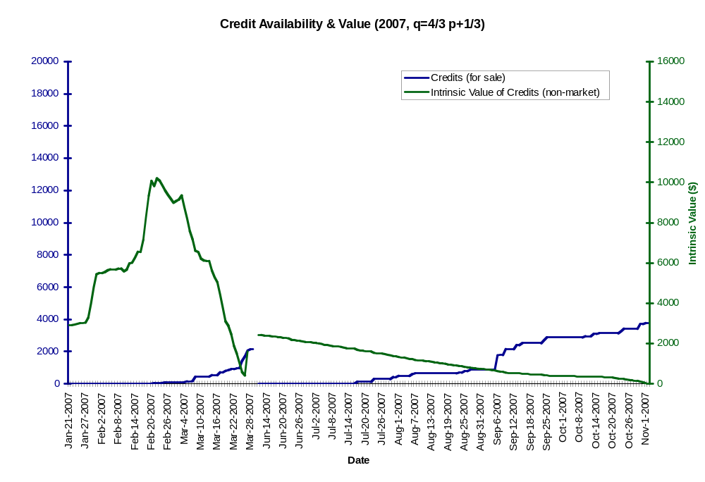

Note that while the PPA wording uses abundance, bycatch rate or encounter rate is the defacto proxy for Chinook abundance (bycatch rate = [# Chinook caught] / [1 metric ton of Pollock]).
Dynamic Salmon Savings retires a variable fraction of the excess ITEC remaining after each vessel has completed its Pollock harvest, diminishing the supply of tradable credits in low to moderate encounter times.
Rico 1995, The U.S. allowance trading system for sulfur dioxide: An update on market experience, Environmental and Resource Economics Volume 5, Number 2 / March, 1995
Chinook encounter rate = bycatch rate = [#Chinook caught] / [1 metric ton of Pollock]
Note: for analyses based on the annual data, allocations with P are based on annual averaged bycatch rates.
Note: that when α=γ the upper and lower bounds on P do not change with different weightings.

